DOCKER task- 03
- Create a image from running container.

- Pull nginx image
- Use command: docker pull nginx
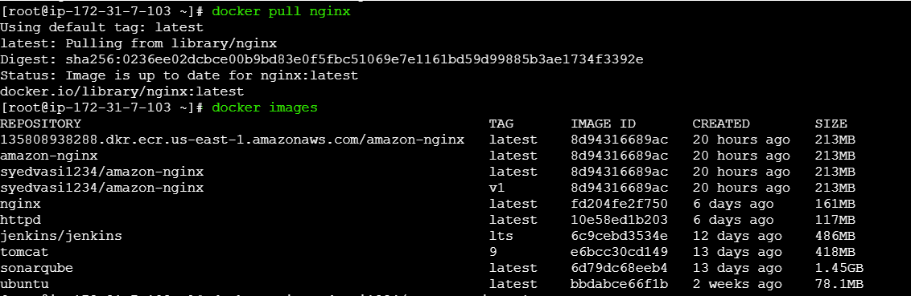
- Run nginx container
Use command: docker container run -itd -p 81:80 --name nginx-container nginx:latest
- Verified container using command: docker ps
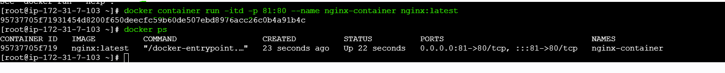
- Entered running container
use command: docker exec -it nginx-container /bin/bash
- Changed the content in index.html
- Created image for container use command: docker commit nginx-container custom-nginx:v1
- Image has been created successfully
- Verified image using command: docker images
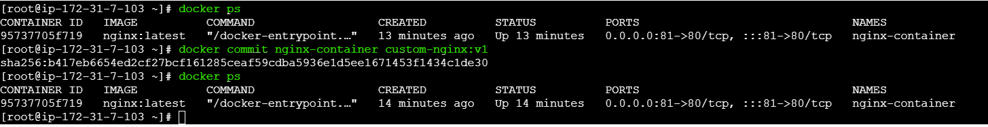
- Now using public Ip of ec2 verify in browser
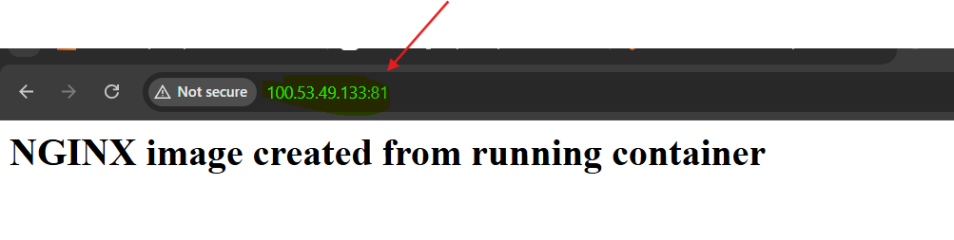
- Copy image from local machine to docker server and load the image.

Steps performed:
1.Logged in to Docker Hub in gitbash .
Command: docker login
2.Pulled nginx image on local machine
Command: docker pull httpd:latest
3.Verified nginx image locally
Command: docker images
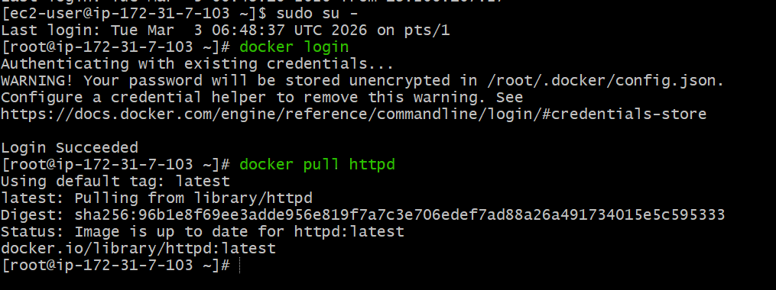
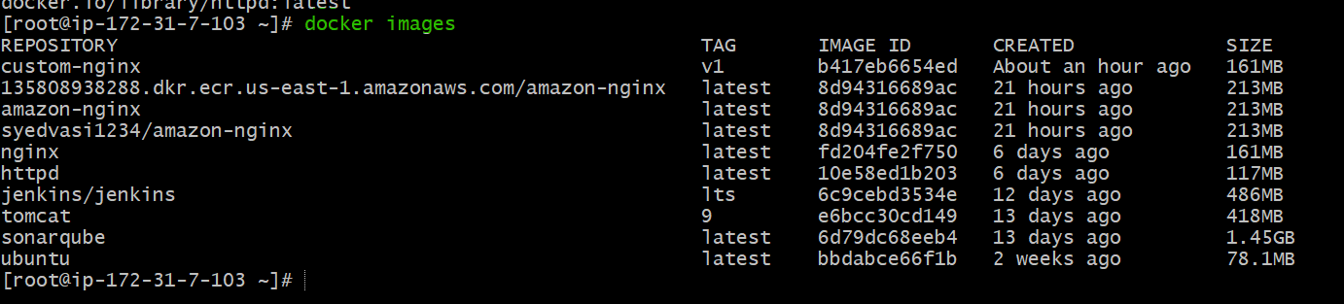

4.Saved httpd image to tar file on local machine
Command: docker save httpd:latest -o httpd.tar
5.Verified tar file creation
Command: ls -lh httpd.tar
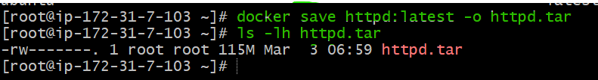
6.Copied httpd image tar from local machine to docker server
Command: scp -i logical.pem httpd.tar ec2-user@100.53.49.133:/home/ec2-user
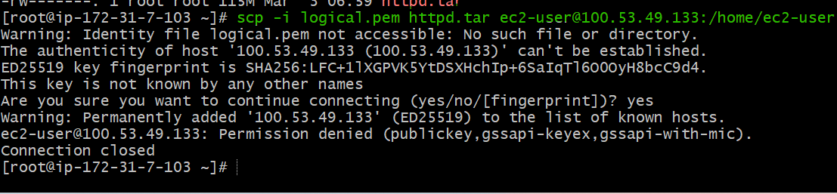
7.Verified httpd.tar file on EC2
Command: ls
8.Loaded httpd image into Docker on EC2
Command: sudo docker load -i httpd.tar
9.Verified nginx image on EC2
Command: sudo docker images.
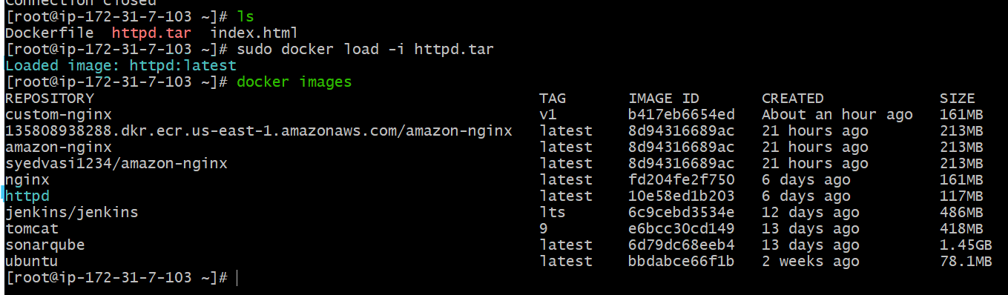
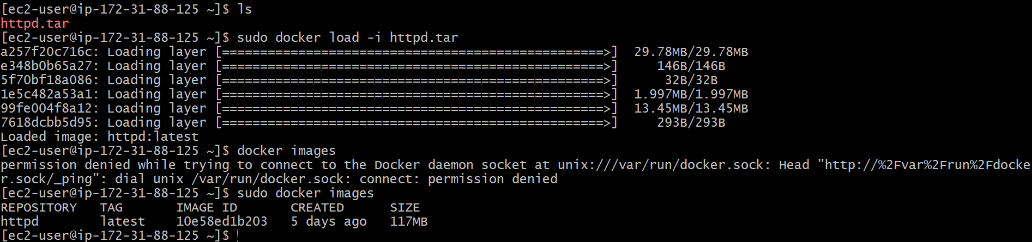

- Create Docker image using alpine and customize with tomcat.

Step 1: Create Project Directory
mkdir tomcat-alpine
cd tomcat-alpine
Step 2: Create Dockerfile
vi Dockerfile
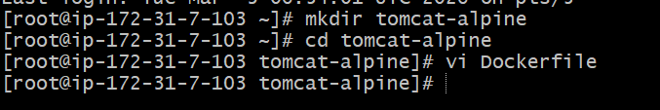
Step 3: Dockerfile for Tomcat (Alpine Based)
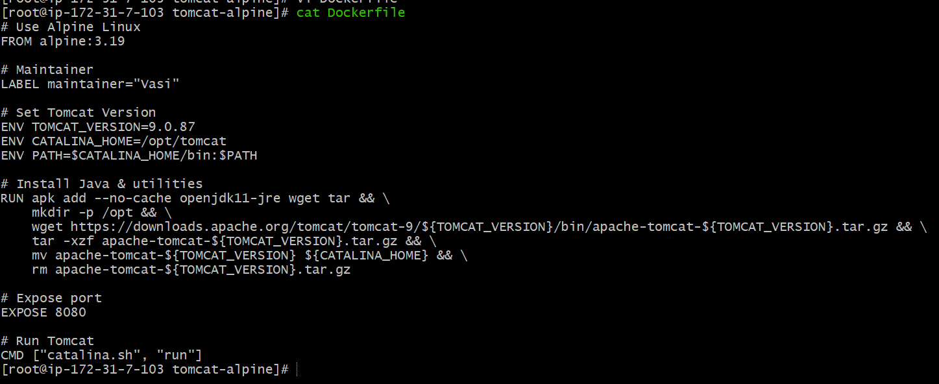
Step 4: Build Docker Image
docker build -t tomcat-alpine:latest .

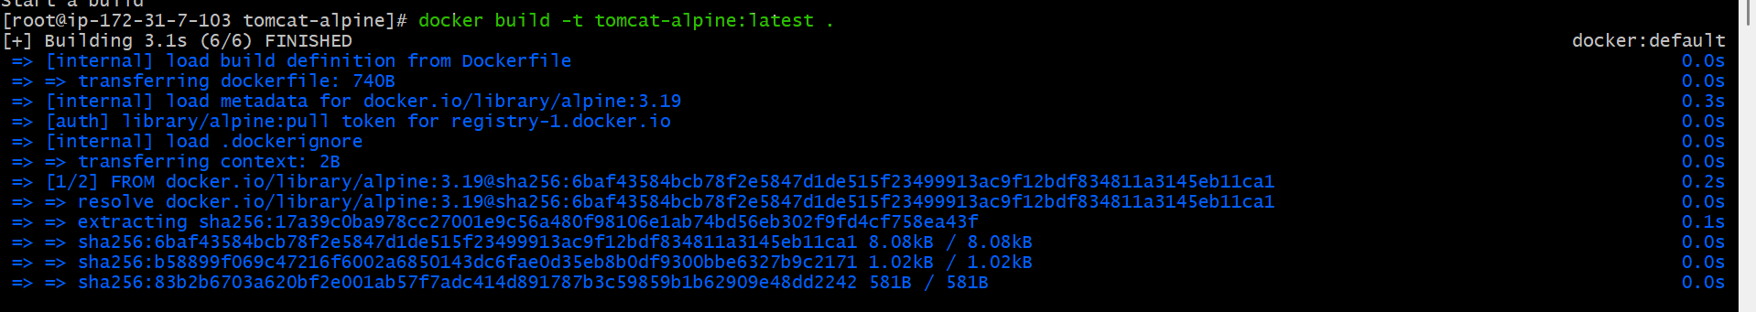
Check image:
docker images
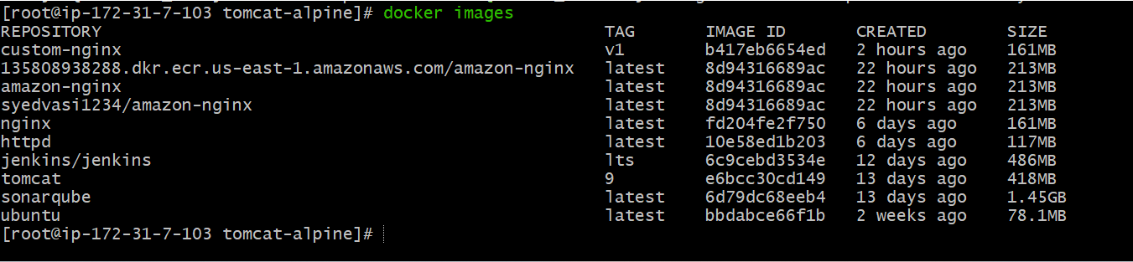
Step 5: Run Container
docker run -d -p 8080:8080 tomcat-alpine
Check running containers:
docker ps
Step 6: Verify in Browser
Open:
http://localhost:8080
Tomcat should be running.
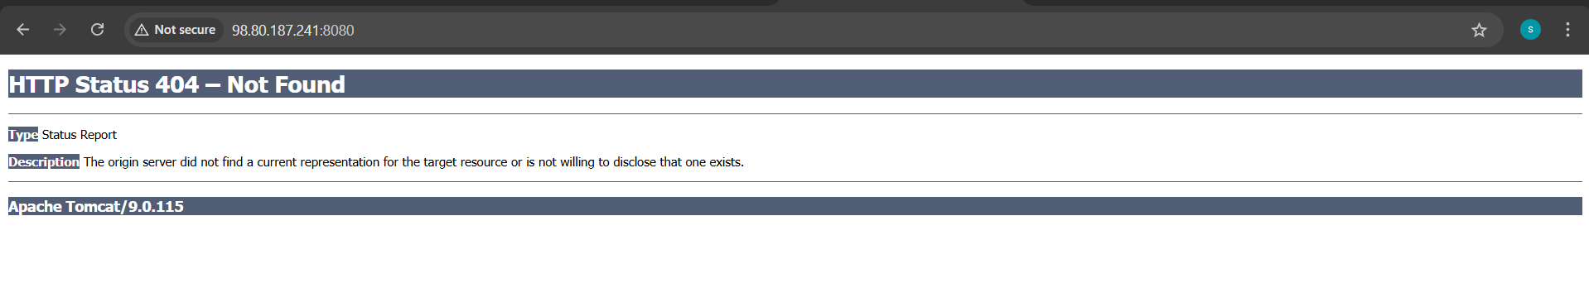
Optional: Deploy WAR File
Add this line inside Dockerfile before `EXPOSE`:
COPY myapp.war ${CATALINA_HOME}/webapps/
Rebuild:
docker build -t tomcat:9.0.115-alpine .

- Create single stage and multi stage docker file using this source code: https://github.com/betawins/multi-stage-example.git

PART 1: Single-Stage Dockerfile – Steps Performed
1.Cloned the source code repository
git clone https://github.com/betawins/multi-stage-example.git
2.Navigated to the project directory
cd multi-stage-example
3.edited the Dockerfile
vi Dockerfile
4.Added single-stage Dockerfile content (Maven build + run in same image)
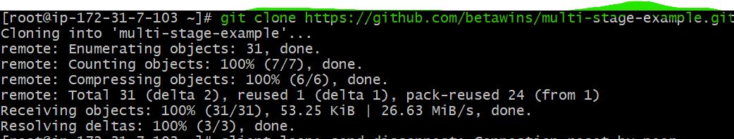
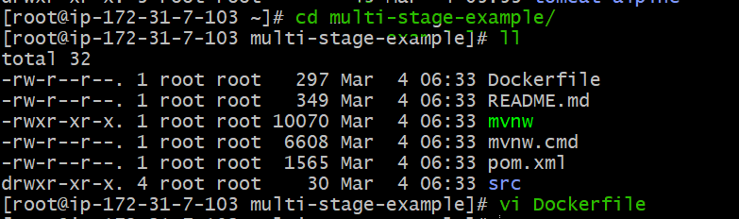
5.Verified Dockerfile content
cat Dockerfile
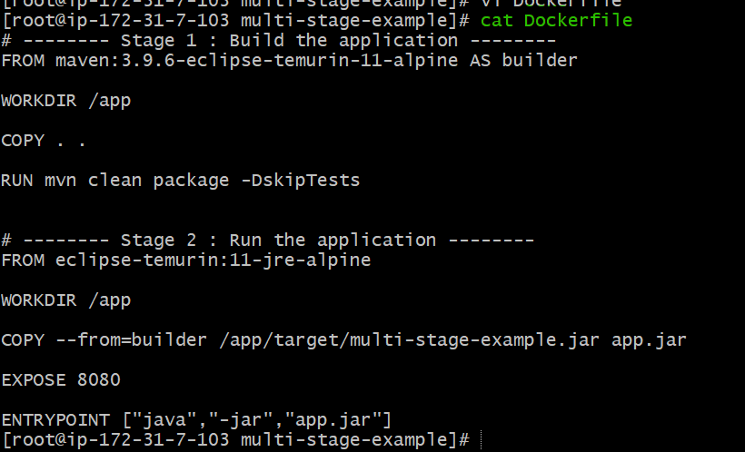
6.Built the single-stage Docker image
docker build -t single-stage:latest .
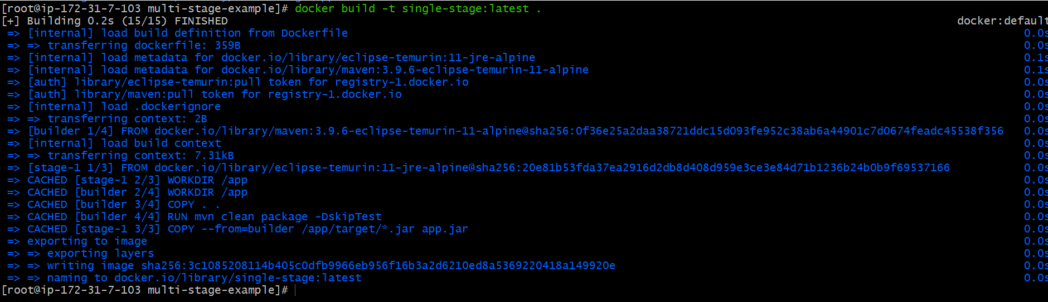
7.Verified the Docker image creation
docker images
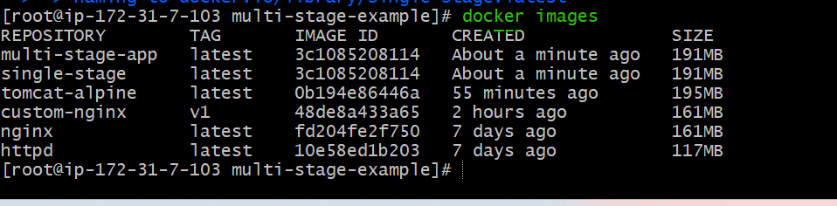
8.Ran the single-stage application container with port mapping
docker run -d -p 8081:8080 single-stage

9.Verified the running container
docker ps
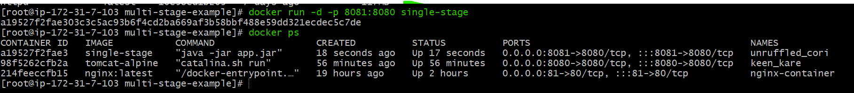
10.Accessed the application from browser
Browse: http://public-ip:8081
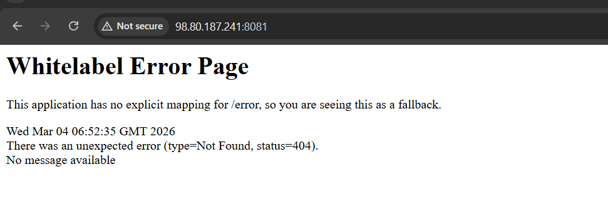
PART 2: Multi-Stage Dockerfile – Steps Performed
1.Opened the project directory
cd multi-stage-example
2.Edited the Dockerfile for multi-stage build
vi Dockerfile
3.Added multi-stage Dockerfile with build stage and run stage
4.Verified Dockerfile content
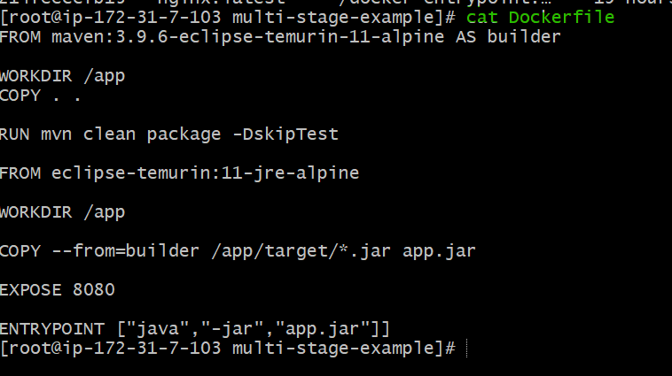
5.Built the multi-stage Docker image
docker build -t multi-stage:v1 .
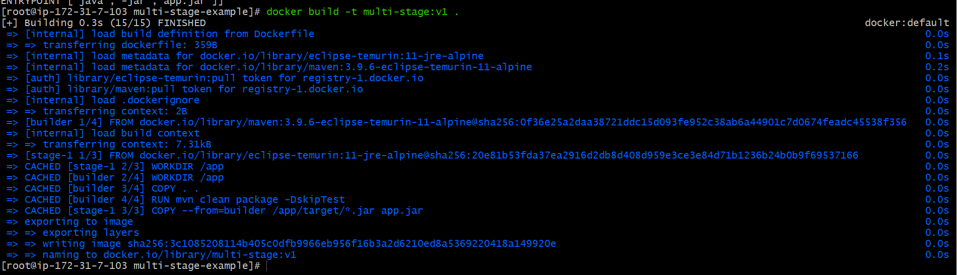
6.Verified the multi-stage image creation
docker images
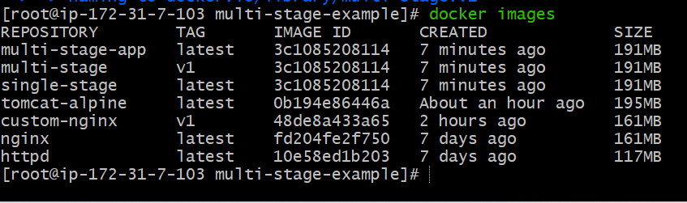
7.Ran the multi-stage container with port mapping
docker run -d -p 8083:8080 multi-stage:v1
8.Verified the running container
docker ps
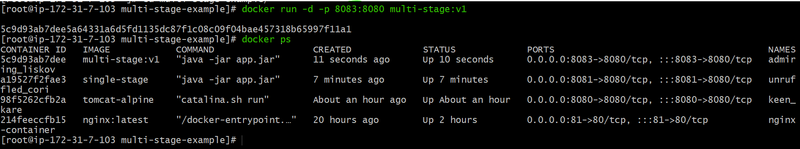
9.Accessed the application from browser
Browse: 98.80.187.241:8083
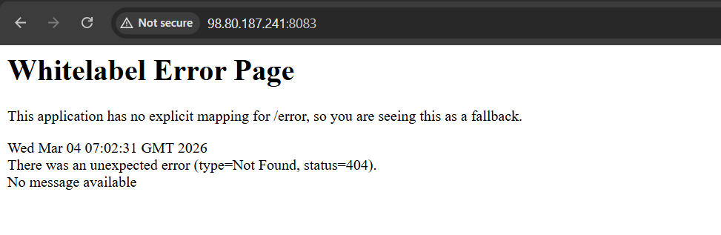
Feature | Single-Stage Dockerfile | Multi-Stage Dockerfile
Base image | Maven image (build + run together) | Maven (build) + JRE (run)
Build tools in final image | Present (Maven, source code) | Removed
Image size | Large (~465 MB) | Smaller (~273 MB)
Security | Less secure | More secure
Best for | Learning, testing | Production
Build time | Slightly faster | Slightly slower
Runtime efficiency | Lower | Higher

Feature | Single-Stage Dockerfile | Multi-Stage Dockerfile
Base image | Maven image (build + run together) | Maven (build) + JRE (run)

- Install docker compose and execute sample application.

Step 1: Check Docker Version
docker --version
If Docker is running, continue.
Step 2: Install Docker Compose (Standalone Binary)
Run this:
sudo curl -L "https://github.com/docker/compose/releases/latest/download/docker-compose-linux-x86_64" -o /usr/local/bin/docker-compose
Give execute permission:
sudo chmod +x /usr/local/bin/docker-compose
Verify:
docker-compose --version
You should see something like:
Docker Compose version v5.x.x

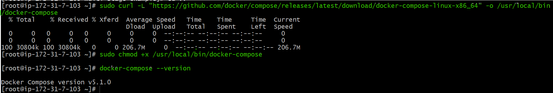
Step 3: Create Nginx Application

Create compose file:
vi docker-compose.yml
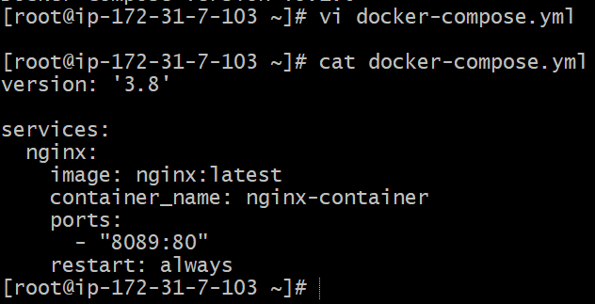
Step 4: Run Nginx
docker-compose up -d
Check container:
docker ps
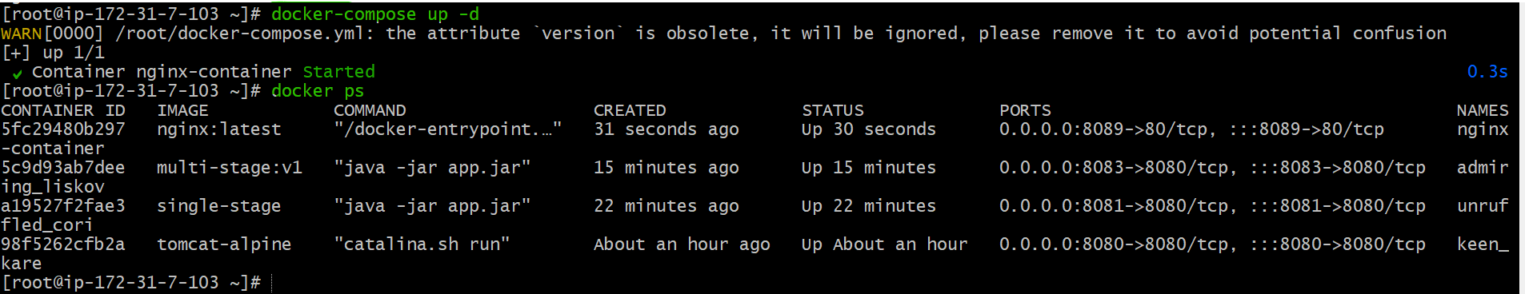
Step 5: Allow Port 8089 (Important on EC2)
If this is an EC2 instance:
Go to **Security Group**
Add inbound rule:
* Type: Custom TCP
* Port: 8089
* Source: 0.0.0.0/0 (for testing)
Step 6: Access Application
Open:
http://<EC2-public-ip>:8089
You should see Nginx welcome page

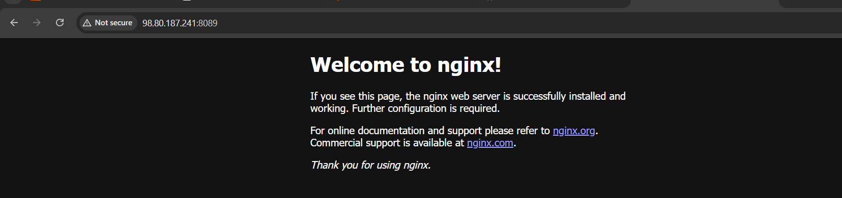

- Implement solution to scan images when pushed to docker registry.

Steps performed:
1.Opened Docker Hub repository settings for syedvasi1234/amazon-nginx
2.Enabled Docker Scout image analysis in repository settings and saved changes
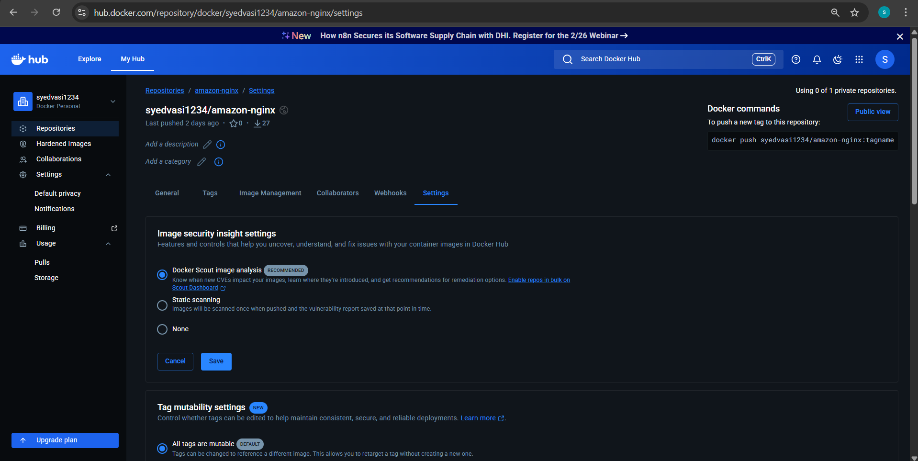
3.Logged in to Docker Hub from Docker server
docker login
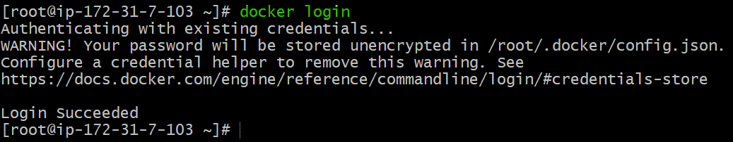
4.Tagged the local Docker image for Docker Hub repository
docker tag multi-stage:latest aniketh1234/amazon-nginx:latest
5.Verified the tagged image locally
docker images
6.Pushed the image to Docker Hub repository
docker push aniketh1234/amazon-nginx:latest
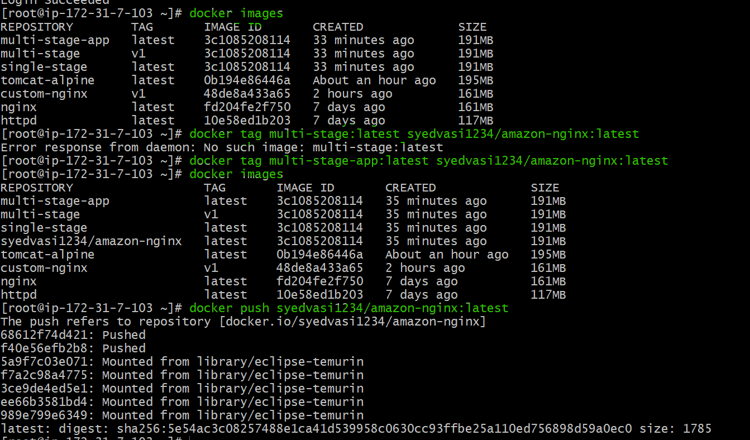
7.Verified successful image push (digest displayed in terminal)
8.Opened Docker Hub and verified the image krishnav7090/amazon-nginx: v1 appeared under Images
9. Viewed image layers and vulnerability scan results in Docker Hub
10. Confirmed image details such as base image, exposed port, CMD, size, and CVE list displayed successfully
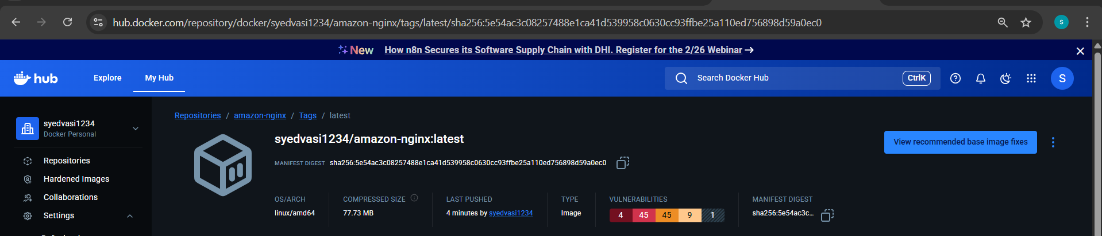

- Implement solution to scan images when pushed to AWS ECR.

Steps performed:
1.Created an Amazon ECR repository in us-east-1
aws ecr create-repository \
--repository-name new-ecr-repo \
--region us-east-1
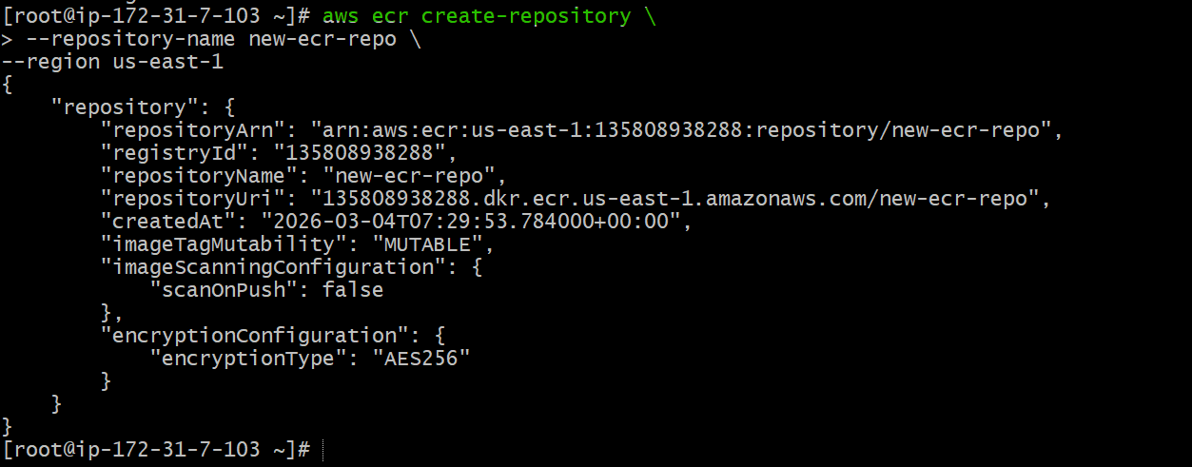
2.Verified repository details and observed scanOnPush was false
3.Enabled image scan on push for the ECR repository
aws ecr put-image-scanning-configuration \
--repository-name new-ecr-repo \
--image-scanning-configuration scanOnPush=true \
--region us-east-1
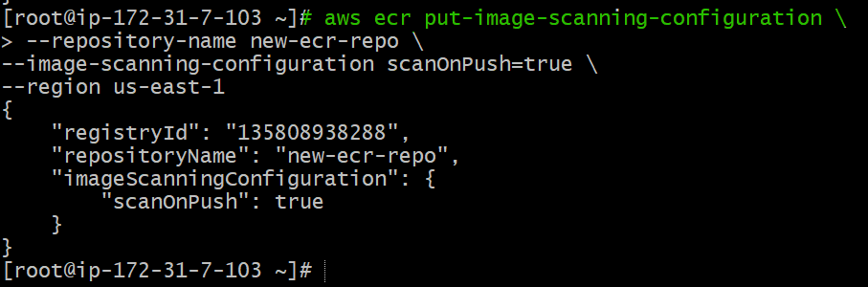
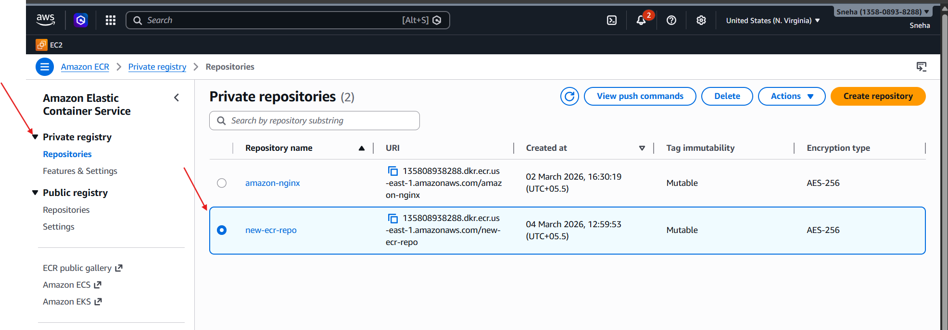
4.Logged in to Amazon ECR using AWS CLI
aws ecr get-login-password --region us-east-1 | docker login --username AWS --password-stdin 603455139217.dkr.ecr.us-east-1.amazonaws.com
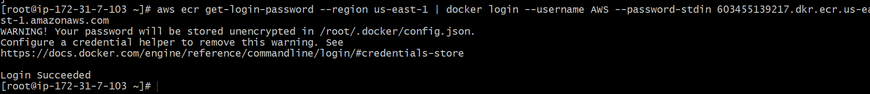
5.Tagged the local Docker image for ECR
docker tag httpd:latest 603455139217.dkr.ecr.us-east-1.amazonaws.com/new-ecr-repo:latest
6.Verified the tagged image locally
docker images
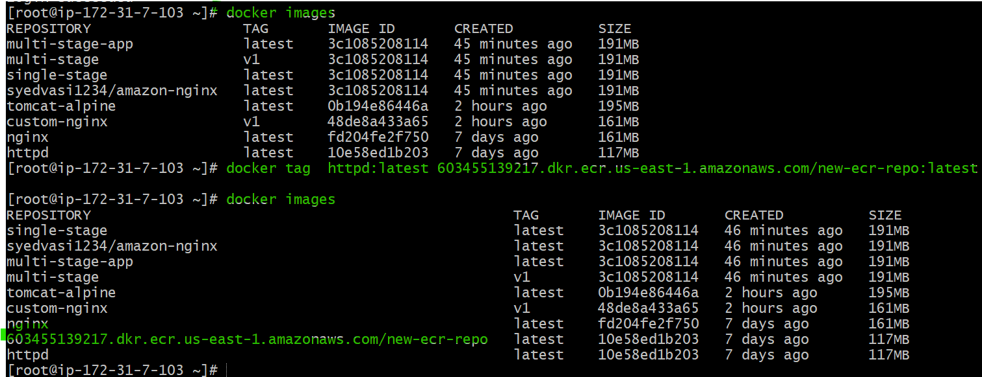
7.Pushed the Docker image to Amazon ECR

docker push 603455139217.dkr.ecr.us-east-1.amazonaws.com/new-ecr-repo:latest
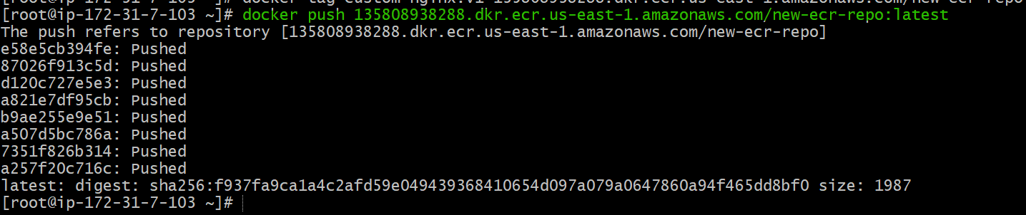
8. Verified image availability in the ECR repository (AWS Console → Images tab)
9. Opened image details in ECR and confirmed scan completed successfully
10. Verified vulnerability scan results showed 0 Critical, 0 High, 0 Medium, 0 Low, 0 Info
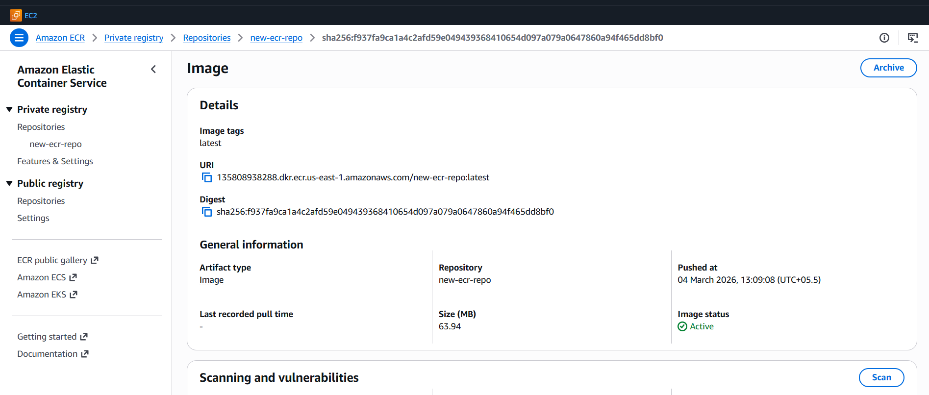
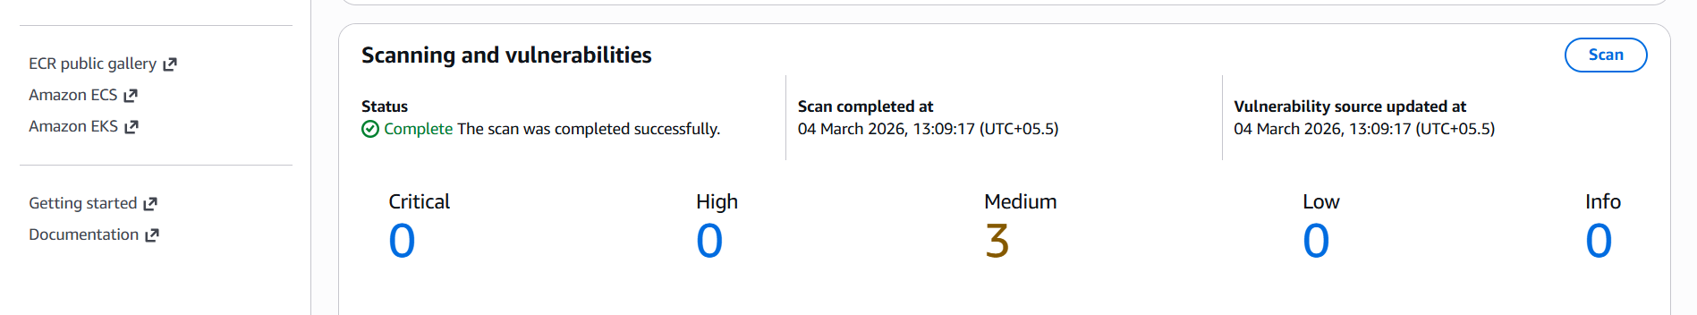
- Create a Jenkins pipeline to create a docker image and push the image to Docker hub.

Step 1: Install Required Tools on Jenkins Server
Make sure your Jenkins server has:
Install Docker
sudo yum install maven -y
sudo yum install docker -y
sudo systemctl start docker
sudo systemctl enable docker
Add Jenkins user to Docker group:
sudo usermod -aG docker jenkins
sudo systemctl restart jenkins
Install Jenkins Docker Plugin
Go to:
Manage Jenkins → Manage Plugins → Available Plugins
Install:
✅ Docker Pipeline
✅ Docker Commons
✅ Docker
✅ Git
✅ pipeline
Step 2: Create Docker Hub Credentials in Jenkins
1. Go to:
Manage Jenkins → Manage Credentials
2. Click:
(Global) → Add Credentials
3. Select:
Username with password
4. Enter:
* Username: your Docker Hub username
* Password: your Docker Hub password
* ID: `docker`
* Description: Docker Hub Credentials
Click **Save**.

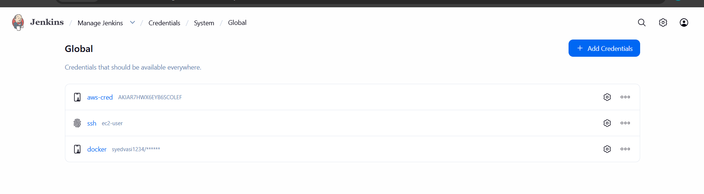
Step 3: GitHub Repository Setup
•Created GitHub repository:

•https://github.com/wallmore/docker-pipeline

•Add the Dockerfile
Dockerfile content :
FROM nginx:alpine
COPY . /usr/share/nginx/html
EXPOSE 80
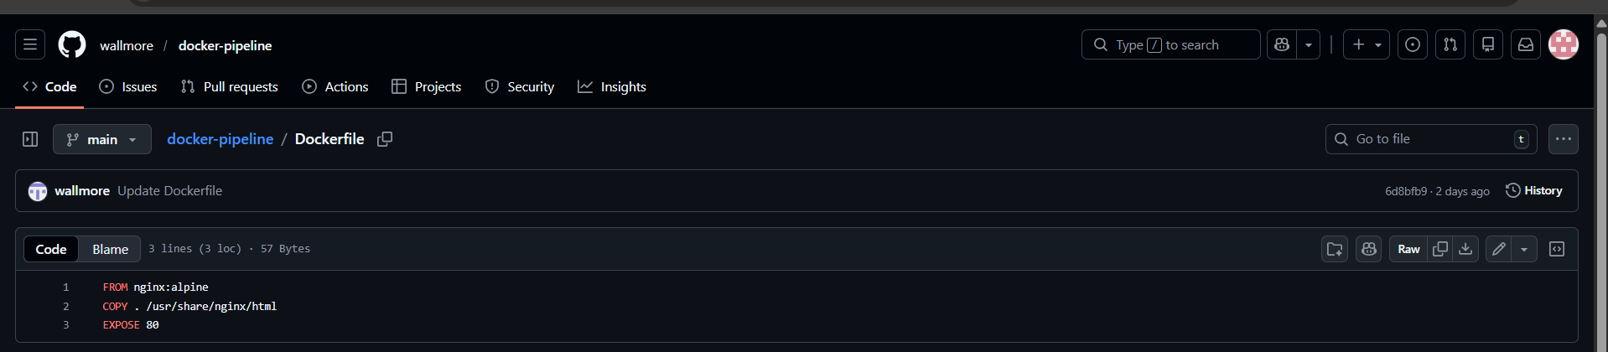
Step 4: Create Jenkins Pipeline Job
1. Go to Jenkins Dashboard
2. Click **New Item**
3. Enter name → `docker-pipeline`
4. Select → **Pipeline**
5. Click OK

Step 5: Add Jenkinsfile (Pipeline Script)
Go to:
Pipeline → Definition → Pipeline Script

Paste this:
pipeline {
agent any

environment {
DOCKER_IMAGE = "syedvasi1234/amazon-nginx"
DOCKER_TAG = "version-1"
}

stages {

stage('Checkout Code') {
steps {
git branch: 'main',
url: 'https://github.com/wallmore/docker-pipeline.git'
}
}

stage('Build Docker Image') {
steps {
sh 'docker build -t $DOCKER_IMAGE:$DOCKER_TAG .'
}
}

stage('Login to Docker Hub') {
steps {
withCredentials([usernamePassword(
credentialsId: 'docker',
usernameVariable: 'DOCKER_USER',
passwordVariable: 'DOCKER_PASS'
)]) {
sh '''
echo $DOCKER_PASS | docker login -u $DOCKER_USER --password-stdin
'''
}
}
}

stage('Push Docker Image') {
steps {
sh 'docker push $DOCKER_IMAGE:$DOCKER_TAG'
}
}
}

post {
success {
echo "Image pushed successfully "
}
failure {
echo "Pipeline failed "
}
}
}

Step 6: Build the Pipeline
Click:
Build Now
If successful, you will see:
Successfully pushed yourdockerhubusername/myapp:latest
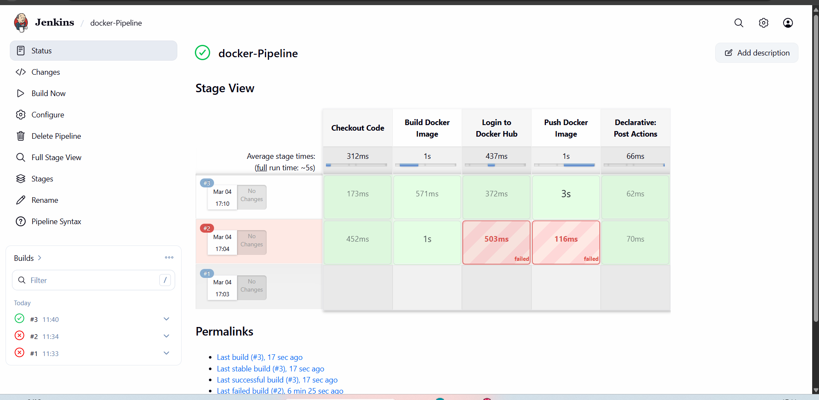
Step 7: Verify on Docker Hub
Login and check your repository.
